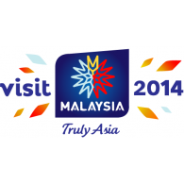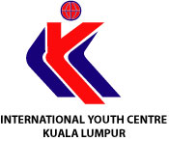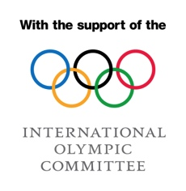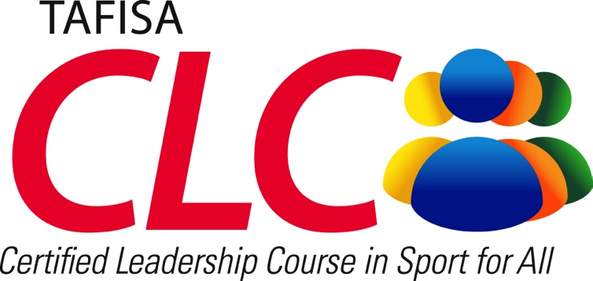

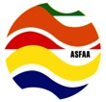

**ASFAA**



**MARFIMA**

*in cooperation with IOC*

***4th to 10th May 2014, Kuala Lumpur, Malaysia***

**TAFISA**

TAFISA (The Association For International Sport for All) is the leading international Sport for All organisation with more than 250 members in 150 countries. TAFISA works in close cooperation with international organisations such as the IOC, UN, UNESCO and ICSSPE. TAFISA aims for an Active World by promoting Sport for All and physical activity globally, and providing practical programs and events, as well as networking opportunities and development support for its members around the world. Learn more about TAFISA at [www.tafisa.net](http://www.tafisa.net).

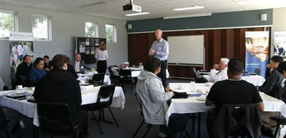**TAFISA Certified Leadership Courses, in cooperation with IOC**

TAFISA Certified Leadership Courses (CLCs) in Sport for All were developed in 2007, and because of their success have enjoyed the support of the IOC since 2010. TAFISA CLCs aim to educate and qualify national Sport for All leaders, managers, volunteers and NOCs from around the globe.

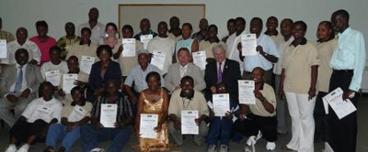The five day course typically invites a maximum of 30 local and regional participants. Participants enjoy a fantastic educational program, as well as sports, social and sightseeing programs. Of course, the CLCs provide an excellent opportunity for national and regional networking!

Each CLC concludes with an oral examination and graduates receive a course certificate acknowledging their participation and contribution.

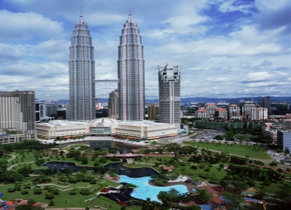 **Malaysia & Kuala Lumpur**

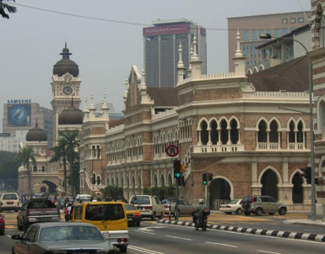Malaysia is a tropical country situated in the heart of Southeast Asia. It is renowned as spectacular with coastal plains rising to hills and mountains. The culture of Malaysia has arisen from the mingling of immigrant traditions with those of indigenous Malays. This is a land where religious traditions sit in harmony with modern technological advances.

Kuala Lumpur (KL) is one of Asia's most cosmopolitan and modern cities, despite housing many beautiful old buildings, green areas and friendly charm. KL offers a unique blend of old colonial and new Asian style, where Chinese tea houses, Indian shops and Malay hawker stalls line streets next to world-class hotels and hi rise office blocks. The city brings together Malaysia's past and present, allowing first-time visitors an invaluable opportunity to see Malaysia as a whole before setting off to explore its parts.

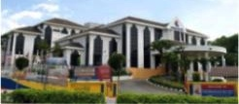**CLC Venue**

The International Youth Centre, Cheras, Kuala Lumpur, is conveniently located at Bandar Tun Razak, in close proximity to recreation facilities, sports and aquatic centres and Kuala Lumpur city centre. IYC has air-conditioned rooms and a full range of conference facilities.

**Benefits for Participants & Course Inclusions**

|  |  |
| --- | --- |
| * Education & increased qualification * Knowledge & experience transfer opportunities * International networking * Opportunity to showcase own local/national initiatives * Development of English skills | * Development of presentation/public speaking skills * Course materials * Graduation certificate * Sports & social program * Access to international speakers & lecturers |

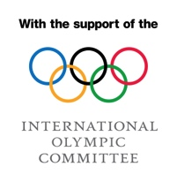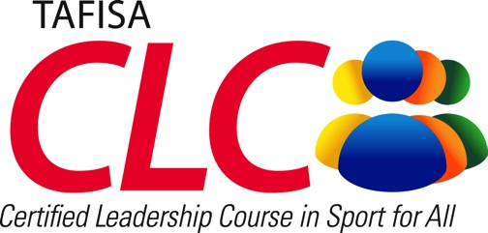



**MARFIMA**



**ASFAA**

*in cooperation with IOC*

***4th to 10th May 2014, Kuala Lumpur, Malaysia***

**Tentative Program**

|  |  |  |  |  |  |  |  |
| --- | --- | --- | --- | --- | --- | --- | --- |
|  | **Day 0** | **Day 2** | **Day 3** | **Day 4** | **Day 5** | **Day 6** | **Day 7** |
|  | **Sunday**  **4th May** | **Monday**  **5th May** | **Tuesday**  **6th May** | **Wednesday**  **7th May** | **Thursday**  **8th May** | **Friday**  **9th May** | **Saturday 10th May** |
| **Morning Session** | Arrival of Speakers & Participants | **The Global Sport for All & Physical Activity Movement – Designed to Move** | **Strategy Development in Sport for All & Physical Activity** | **Marketing, Campaigning, Comm’s & PR** | **Active City, Active Community, Active Citizen** | **Oral Examinations** | Departure of participants |
| **After-noon Session** | **International Sport for All & Physical Activity Programs & Policies** | **Volunteerism in Sport for All, Role of Traditional Games & Sports** | **Kuala Lumpur Sightseeing & Shopping City Tour** | **Assignment & Study Time,**  **Consultation with Lecturers** | **Certificates Presentation, Closing Ceremony** |
| **Evening** | **Greetings & Introduction**  **Welcome Reception** | **Dinner with Guest Speaker** |  | Departure of participants |

**TAFISA Accredited Lecturers & Speakers Organising Committee**

|  |  |
| --- | --- |
| * Dato' Sarjit Singh Sekhon, Malaysia * Prof. Henry Daut, Philippines * Asst. Prof. Ravi M. Sahu, India | * Datuk M. Mohandas - Chairman Program Organising Committee * Mr V.S. Maniam - Head of Secretariat |

**Indicative Costs**

The Registration Fee per participant is US$350 for twin shared room, or US$400 for a single occupancy room. This includes course registration fee, accommodation, local transport, meals, social program and course materials. Confirmed attendees will be invoiced following receipt of the Registration Form.

**Visa Organisers Supporters**

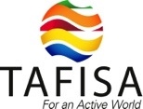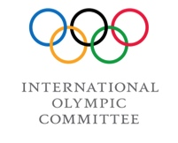For those participants requiring a visa and wishing to apply at the Malaysian Consulate or Embassy in their country, MARFIMA will supply a formal letter of invitation following receipt of the Registration Form and Fee.



**ASFAA**



**MARFIMA**

**More Information**

Please note attendance is limited and will be based on a date of reply basis. For more information, contact:

## TAFISA

[info@tafisa.net](mailto:info@tafisa.net) ▪ [www.tafisa.net](http://www.tafisa.net)

Tel: +49 69 97 393 59900

Fax: +49 69 97 393 59925